**The hall of entrepreneurs, patrons and benefactors of the 19th - early 20th century**

1. **Read the description of T.F. Bolshakov given by P.A. Bessonov, and match it to one of the portraits below:**

A tall, venerable old man with yellowed gray hair, with an unusually intelligent and stern face, with a slow, serious speech. He doesn’t invite you, everyone goes to him anyway. He does not shuffle, does not beckon with a friendly smile, but respectfully returns a bow, accepts anyone, even a young student. From the start he talks about Russian science and literature, mainly about antiquity, about remote history, about ancient monuments, manuscripts and books.

1) 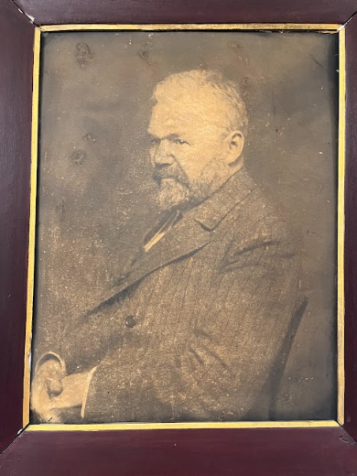 2) 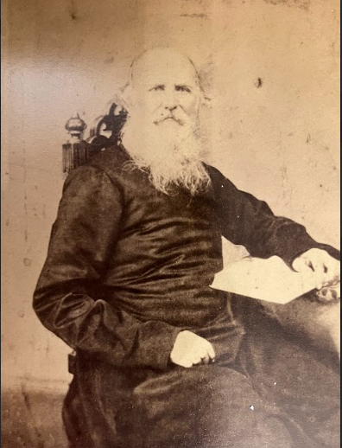 3) 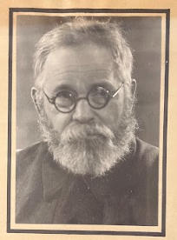

**2. Study the information in the showcase devoted to the Bolshakov family and complete the sentences:**

1. The Bolshakovs’ trade business existed in Moscow …….

a) for a short time;

b) for over a hundred years;

c) only in the 19th century.

2. T.F. Bolshakov started his business with ……..

a) trading leather goods;

b) trading antique books;

c) textile production.

3. He became engaged exclusively in second-hand bookstores because of his interest in ………….

a) printing books;

b) antique books;

c) church utensils.

4. T. Bolshakov bought ancient manuscripts and books all over Russia with the help of……..

a) his friends;

b) famous collectors;

c) a network of sales agents.

5. T. Bolshakov’s collection is the basis of the Department of Manuscripts in ……………

a) the Hermitage;

b) the Russian State Library;

c) Moscow State University.

**3. Comment on the exhibit situated in the showcase devoted to the Bolshakovs:**



